

Computer Network Theory

Assignment # 2

Instructor Name Razia Nisar Noorani

Computer Network Theory
BS Computer Science, Batch 2022F

Case study on Bit Torrent & Netflix

Group Members:
Name | Roll Number
Saad Ali | 2022F-BCS-162
Muzamil | 2022F-BCS-316
Muhammad Faisal | 2022F-BCS-152
Afnan | 2022F-BCS-168

Supervisor

Case Study

Q1) Write a Case study on Bit Torrent. Write detailed working with diagrams.
The BitTorrent protocol is a peer-to-peer (P2P) file-sharing protocol designed to efficiently distribute large files over the Internet by breaking them into smaller pieces. Here's how it works and how it differs from traditional file-sharing methods:

How BitTorrent Protocol Works
- File Segmentation:
  - A large file is divided into small pieces, usually of uniform size (e.g., 256 KB or 512 KB).
  - These pieces are hashed, creating unique identifiers to ensure data integrity.
- Torrent File and Tracker:
  - A .torrent file contains metadata about the file being shared, including piece hashes, the file name, and a list of tracker servers.
  - The tracker coordinates peers by maintaining a list of available users sharing the file.
- Swarm Formation:
  - When a user downloads a torrent file and opens it in a BitTorrent client, the client connects to the tracker to find peers (other users who either have or are downloading the file).
  - The network of all peers sharing the same file is called a swarm.
- Downloading and Uploading:
  - Peers download pieces of the file from multiple other peers and upload the pieces they already have.
  - Each peer contributes bandwidth, reducing the load on any single source.
- Seeders and Leechers:
  - A seeder has the complete file and only uploads to other peers.
  - A leecher is still downloading pieces of the file but can upload the pieces they already have to others.
- Piece Exchange Algorithm:
  - BitTorrent uses a "tit-for-tat" algorithm to prioritize peers who upload more. This incentivizes sharing.
  - Once a peer completes downloading all pieces, it becomes a seeder.
- Decentralization:
  - BitTorrent can also function without centralized trackers using Distributed Hash Tables (DHT), allowing peers to find each other without a server.

Differences from Traditional File-Sharing
- Decentralized Distribution:
  - Traditional file-sharing methods (e.g., HTTP, FTP) rely on a central server to host and distribute files.
  - BitTorrent distributes files among peers, reducing server dependency and bandwidth costs.
- Simultaneous Upload/Download:
  - In traditional methods, users only download files from the server.
  - In BitTorrent, users both upload and download, increasing the speed and efficiency of file distribution.
- Swarm Dynamics:
  - File transfer speeds increase with more peers in BitTorrent, as pieces come from multiple sources.
  - Traditional methods can slow down or fail under high demand.
- Resilience to Failures:
  - If the central server goes offline in traditional methods, file sharing stops.
  - BitTorrent works as long as there are active peers in the swarm, even without a tracker.

The Role of Seeders and Leechers in a BitTorrent Network and Their Contribution to File Distribution Efficiency
In a BitTorrent network, "seeders" and "leechers" play crucial roles in the file distribution process.
- Seeders: These are users who have a complete copy of the file and continue to share it with others. They upload pieces of the file to leechers and other peers. The more seeders there are, the more sources there are to download the file from, which helps increase the speed and availability of the file. Seeders ensure that the file remains accessible to others over time.
- Leechers: These are users who are in the process of downloading the file but may not have the complete file yet. They also contribute to the distribution of the file by uploading the parts they have downloaded to other peers. Although leechers primarily focus on downloading, their participation in uploading makes the network more efficient.
Seeders and leechers contribute to the efficiency of file distribution in the following ways:
- Seeders:
  - They provide the complete file to the network, ensuring that the file is always available for download.
  - Since they have the entire file, they can continuously upload parts to other peers, increasing the overall speed and availability of the file.
  - The more seeders there are, the more sources there are to download from, reducing the chances of bottlenecks or slow downloads.
- Leechers:
  - Even though leechers are primarily downloading, they contribute to the network by uploading parts of the file they have already downloaded to others.
  - This helps distribute the file across multiple peers, making the system more efficient and reducing the dependency on seeders alone.
  - Leechers' simultaneous downloading and uploading increase the overall throughput of the network, especially in cases where there are more leechers than seeders.
Together, seeders and leechers create a self-sustaining system. As leechers download and upload, they keep the file distribution process active and ensure that the network does not rely on a single point of failure. This decentralized approach leads to faster downloads, more efficient sharing, and greater resilience in the network.
The Concept of a Torrent File in BitTorrent and Its Role in Facilitating File Sharing
A "torrent file" is a small file that contains metadata about the files you want to share, but not the actual content of the files themselves. It plays a crucial role in the BitTorrent protocol and facilitates the sharing of large files across the network in the following ways:
- Metadata Storage:
  - The torrent file includes information about the files you are downloading or uploading, such as file names, sizes, and folder structures.
  - It also contains information about the tracker, which helps coordinate the file-sharing process and find peers in the network.
- Piece Information:
  - Torrents break large files into smaller chunks or "pieces." The torrent file includes details about how the file is divided into these smaller pieces, allowing peers to download parts of the file from multiple sources simultaneously.
  - This division into smaller pieces makes it easier to download files in parallel from different peers, speeding up the process.
- Tracker Information:
  - The torrent file contains URLs of the tracker(s) that help find peers. The tracker is responsible for coordinating the connection between peers, ensuring that they can share pieces of the file with each other.
  - While the tracker manages the initial peer discovery, BitTorrent also supports a decentralized model where peers can find each other without needing a central tracker (using Distributed Hash Tables or DHT).
- Efficient File Sharing:
  - Once the torrent file is opened by a BitTorrent client, it uses the metadata to locate other peers that have parts of the file. Peers can then exchange pieces of the file based on availability.
  - This decentralized approach reduces the load on a single server and ensures that large files can be shared efficiently across a network of users.
By providing the necessary metadata and instructions for how files are split and shared, the torrent file enables efficient and fast distribution of large files without relying on a central server. This makes BitTorrent particularly useful for sharing large amounts of data like movies, software, or large datasets.
BitTorrent vs Other Methods
Advantages of BitTorrent
- Faster Download Speeds: With BitTorrent you download pieces of a file from multiple users at the same time. This means faster download speeds especially for large files.
- Distributed Network: BitTorrent doesn't rely on a single server. This makes it more resilient and less prone to crashes.
- Seeders and Leechers: Once you finish downloading a file you become a "Seeder" and help others download it. This creates a self-sustaining network.
Disadvantages of BitTorrent
- Legal Concerns: BitTorrent is often used to share copyrighted material which can lead to legal trouble.
- Security Risks: Downloading from untrusted sources can expose you to malware and viruses.
- Bandwidth Consumption: Uploading parts of the file can consume a lot of bandwidth.
Comparison with Other Methods
Direct Downloads
- Advantages: Simple and straightforward.
- Disadvantages: Relies on a single server which can be slow and unreliable for large files.
FTP
- Advantages: Good for transferring files between computers.
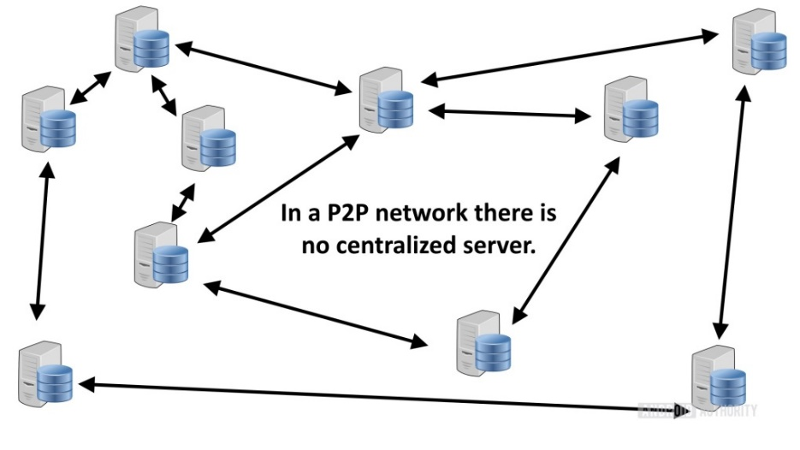
- Disadvantages: Can be slow and limited by server capacity.

Ensuring Data Integrity and Reliability in BitTorrent During File Sharing
BitTorrent ensures data integrity and reliability through a combination of techniques, even when files are split into multiple parts.
Hashing: Each file or file part is assigned a unique hash value, a digital fingerprint generated by a cryptographic algorithm. This hash acts as a checksum, verifying the integrity of the data.
Merkle Tree: For large files, a Merkle tree is used. This is a hierarchical structure where each node represents a hash of its child nodes. By comparing hashes at different levels, clients can verify the integrity of specific parts without downloading the entire file.
Peer Verification: Clients exchange hashes with other peers. If a downloaded piece's hash doesn't match the expected value, it's discarded and requested again from a different peer.
Redundancy: Multiple peers have copies of each file part, increasing the likelihood of obtaining correct data.
Incremental Verification: Clients can verify parts of a file as they download, allowing for early detection of errors.

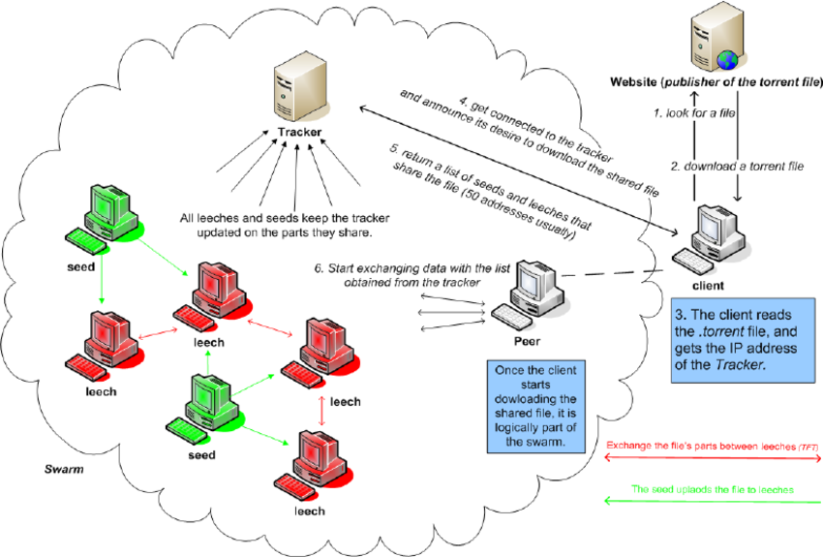

In the diagram:
- File is split into Parts.
- Each Part has a unique Hash.
- Peers exchange Hashes and Parts.
- Clients verify Hashes to ensure data integrity.
- Merkle Tree enables efficient verification of large files.
By employing these mechanisms, BitTorrent significantly enhances the reliability and accuracy of file sharing, even in scenarios where files are divided into multiple parts.

Addressing Copyright Infringement in BitTorrent and Protecting Intellectual Property
BitTorrent, as a protocol, is neutral regarding the content shared over it, but various measures and mechanisms are in place to address copyright infringement and protect intellectual property:

1. Measures Taken by BitTorrent to Address Copyright Infringement
- Tracker Moderation:
  - Some trackers enforce policies to ban torrents associated with copyrighted material.
  - Trackers monitor shared content and can remove infringing files from their listings.
- DMCA Notices:
  - Torrent websites and trackers operating under U.S. jurisdiction comply with Digital Millennium Copyright Act (DMCA) takedown requests.
  - Infringing torrents are removed upon receiving such notices.
- Blocking by ISPs:
  - Internet Service Providers (ISPs) may monitor BitTorrent traffic and block or throttle connections associated with illegal file-sharing.
- Legal Action:
  - Organizations like the Motion Picture Association (MPA) and Recording Industry Association of America (RIAA) track illegal sharing and initiate lawsuits against infringers.

2. How Content Creators Protect Intellectual Property in BitTorrent
- Private Trackers:
  - Creators can use private trackers that require authentication or membership to share files securely with specific audiences.
- Digital Rights Management (DRM):
  - Files distributed via BitTorrent may be encrypted or protected with DRM to restrict unauthorized use.
- Watermarking:
  - Digital watermarking embeds traceable markers in files, enabling creators to track unauthorized sharing.
- Legal Torrents:
  - Content creators can distribute their files via official, licensed torrent websites to control and monetize their content.
- Using BitTorrent Tokens:
  - The BitTorrent Token (BTT) incentivizes users for sharing legitimate content, creating a controlled ecosystem for distributing legal materials.

3. Content Distribution Platforms Using BitTorrent
- Platforms like BitTorrent Now and other authorized portals allow creators to share their work legally, ensuring they retain control over distribution while benefiting from BitTorrent’s efficiency.
By combining enforcement mechanisms, secure distribution practices, and technological safeguards, BitTorrent can balance its efficiency with intellectual property protection.

Common Challenges and Limitations of Using BitTorrent and Solutions
BitTorrent is an efficient file-sharing protocol, but it faces several challenges and limitations. Developers and the community have introduced solutions to address these issues:

1. Bandwidth Throttling by ISPs
- Challenge:
  - Internet Service Providers (ISPs) may throttle or block BitTorrent traffic to reduce network congestion caused by high data usage.
- Solutions:
  - Encryption: BitTorrent clients like uTorrent and qBittorrent offer encryption to hide traffic patterns from ISPs.
  - VPN Usage: Virtual Private Networks (VPNs) help mask BitTorrent activity, preventing throttling or blocking.

2. Copyright Infringement
- Challenge:
  - BitTorrent's decentralized nature makes it easy for users to share copyrighted materials without authorization.
- Solutions:
  - Torrent websites implement content moderation and comply with takedown notices.
  - Platforms encourage legal distribution through private trackers and authorized portals.

3. Peer Availability
- Challenge:
  - Downloads can slow down or fail if there are insufficient seeders or peers.
- Solutions:
  - Incentive Models: Private trackers reward users for seeding by granting higher download speeds or access to exclusive torrents.
  - DHT (Distributed Hash Table): Allows peers to connect directly without relying on central trackers.

4. Malware and Fake Torrents
- Challenge:
  - Malicious users may upload fake torrents containing malware or misleading content.
- Solutions:
  - BitTorrent clients include comment and rating systems for user feedback.
  - Trusted trackers and websites like The Pirate Bay verify and highlight legitimate torrents.

5. Uneven Contribution
- Challenge:
  - Some users, known as leechers, download without contributing back to the swarm, reducing efficiency.
- Solutions:
  - BitTorrent employs a tit-for-tat algorithm, prioritizing peers who share data.
  - Private trackers enforce seeding ratios to ensure balanced sharing.

6. Legal and Ethical Concerns
- Challenge:
  - BitTorrent’s association with piracy has created a stigma, leading to restrictions and bans in certain regions.
- Solutions:
  - Promoting legitimate uses of BitTorrent, such as distributing large datasets or open-source software.
  - Educating users about ethical and legal file sharing.

7. Resource Intensity
- Challenge:
  - BitTorrent clients can be resource-intensive, consuming significant bandwidth and system memory.
- Solutions:
  - Modern clients optimize resource usage with features like bandwidth scheduling and priority-based downloading.
  - Developers create lightweight clients tailored for low-resource environments.
By addressing these challenges through technological innovations and community practices, BitTorrent remains a powerful tool for decentralized and efficient file sharing.
The Evolution of BitTorrent: A Deep Dive
BitTorrent, a decentralized peer-to-peer (P2P) file-sharing protocol, has revolutionized the way we consume digital content. By dividing files into smaller chunks and distributing them across a network of peers, BitTorrent significantly improves download speeds and efficiency. This case study explores the evolution of the BitTorrent protocol, highlighting key improvements and changes that have enhanced its performance and security.
The Birth of BitTorrent
Bram Cohen, a computer programmer, introduced the BitTorrent protocol in 2001. Its innovative approach to file sharing quickly gained popularity due to its ability to handle large file transfers efficiently.
Key Components of BitTorrent
- Torrent File: A metadata file containing information about the file being shared, including its size, hash, and a list of trackers.
- Tracker: A centralized server that coordinates the communication between peers.
- Peers: Individual computers participating in the P2P network.
- Swarm: A group of peers actively sharing a specific file.
Evolution of BitTorrent Protocol
The BitTorrent protocol has undergone significant evolution since its inception. Here are some key improvements:
1. Distributed Hash Table (DHT):
- Centralization Reduction: DHT replaces the centralized tracker with a decentralized network of nodes.
- Improved Resilience: DHT makes the network more resilient to tracker failures.
- Enhanced Peer Discovery: Peers can discover each other directly without relying on a central authority.
2. Magnet Links:
- Direct Peer-to-Peer Sharing: Magnet links allow users to share files directly without the need for a torrent file.
- Simplified Sharing: Users can share files by simply sending a magnet link.
3. Protocol Encryption:
- Enhanced Security: Encryption helps protect user privacy and data integrity.
- Secure Communication: Encrypted communication prevents eavesdropping and tampering.
4. BitTorrent v2:
- Improved Performance: BitTorrent v2 introduces several performance optimizations, such as faster handshake and connection establishment.
- Enhanced Security: Stronger encryption and authentication mechanisms are incorporated.
- Flexible Block Sizes:
Variable block sizes allow for more efficient data transfer.
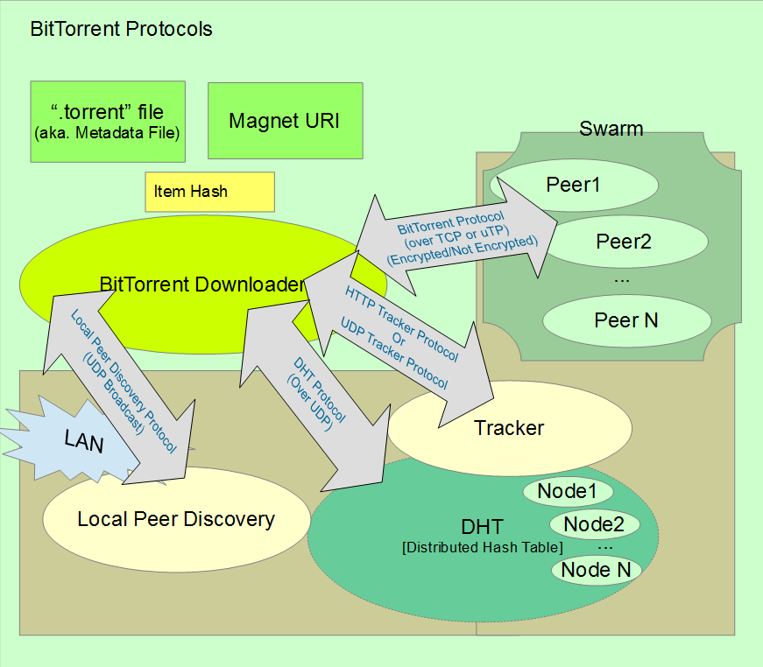
Diagram: Evolution of BitTorrent Protocol

Diagram showing the evolution of BitTorrent, including the original protocol, DHT, magnet links, encryption, and BitTorrent v2
Challenges and Future Directions
Despite its advancements, BitTorrent still faces challenges, including:
- Copyright Infringement: The protocol has been associated with illegal file sharing.
- Network Congestion: Large-scale file sharing can lead to network congestion.
- Security Vulnerabilities: While encryption has improved security, vulnerabilities still exist.
To address these challenges, future developments may include:
- Incentivization Mechanisms: Implementing reward systems to encourage fair sharing and discourage free-riding.
- Enhanced Privacy: Exploring more advanced privacy-preserving techniques.
- Integration with Blockchain Technology: Leveraging blockchain for secure and transparent file sharing.
Conclusion
The BitTorrent protocol has come a long way since its inception. Its innovative approach to decentralized file sharing has made it a popular choice for distributing large files efficiently. By addressing challenges and embracing emerging technologies, BitTorrent can continue to evolve and shape the future of digital content distribution.
Decentralized Tracking in BitTorrent: A Key to Scalability and Resilience
BitTorrent, a popular peer-to-peer file-sharing protocol, relies on decentralized tracking to ensure its scalability and resilience. Unlike traditional centralized tracking systems, where a single server coordinates the network, BitTorrent employs a distributed hash table (DHT) to distribute tracking responsibilities across multiple nodes.

How Decentralized Tracking Works:
- DHT Node Network: The DHT consists of a network of nodes that store and route information about files and peers.
- Peer Discovery: When a peer joins the network, it connects to a random node in the DHT.
- Routing: The DHT uses a distributed algorithm to route queries for specific files to the appropriate nodes.
- Peer Exchange: Nodes in the DHT share information about other peers, enabling direct peer-to-peer connections.
Benefits of Decentralized Tracking:
- Scalability: The DHT can handle a large number of peers without overloading a single server.
- Resilience: The network is more resilient to failures, as there is no single point of failure.
- Censorship Resistance: Decentralization makes it difficult for authorities to censor the network.
- Privacy: By removing the need for a central authority, decentralized tracking can enhance user privacy.
Diagram: Decentralized Tracking in BitTorrent
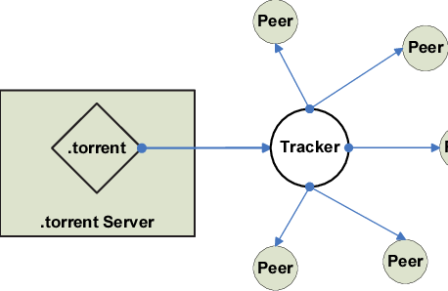

The Diagram illustrating the decentralized tracking mechanism in BitTorrent, showing the DHT, nodes, and peertopeer connections
Real-world Example: The Impact of Decentralized Tracking
During peak usage times, popular torrent sites can experience a surge in traffic. With decentralized tracking, the load is distributed across multiple nodes, preventing any single server from becoming overwhelmed. This ensures smooth operation and prevents bottlenecks, even under heavy load.
In Conclusion
Decentralized tracking is a fundamental aspect of BitTorrent's success. By distributing the tracking responsibilities across multiple nodes, the protocol achieves remarkable scalability, resilience, and censorship resistance. This innovative approach has made BitTorrent a powerful tool for efficient file sharing and content distribution.
Beyond File Sharing: The Versatile Applications of BitTorrent Technology
While BitTorrent is primarily known for its role in peer-to-peer file sharing, its underlying technology has found applications in various industries, offering innovative solutions to diverse challenges.
1. Content Delivery Networks (CDNs):
- Efficient Content Distribution: By leveraging BitTorrent's peer-to-peer capabilities, CDNs can distribute large files efficiently, reducing server load and improving delivery speeds.
- Reduced Bandwidth Costs: By utilizing the bandwidth of peers, CDNs can lower costs associated with content delivery.
2. Software Distribution:
- Faster Downloads: BitTorrent can accelerate software downloads, especially for large applications.
- Reduced Server Load: By offloading the download traffic to peers, servers can handle more users and maintain optimal performance.
3. Data Backup and Synchronization:
- Efficient Data Transfer: BitTorrent can be used to synchronize large files and backups between multiple devices.
- Distributed Backup: Data can be distributed across multiple peers, improving data durability and redundancy.
4. Live Streaming:
- Reduced Server Load: BitTorrent can be used to distribute live streams, reducing the load on the primary servers.
- Improved Streaming Quality: By leveraging peer-to-peer connections, viewers can experience better streaming quality, especially in congested networks.
5. Blockchain and Cryptocurrency:
- Distributed Ledger Technology: BitTorrent's decentralized nature aligns with the principles of blockchain.
- Efficient Data Transfer: BitTorrent can be used to distribute large blockchain blocks and transactions.
6. Scientific Research:
- Data Sharing: Researchers can use BitTorrent to share large datasets efficiently.
- Collaborative Research: The peer-to-peer nature of BitTorrent can facilitate collaboration among researchers.
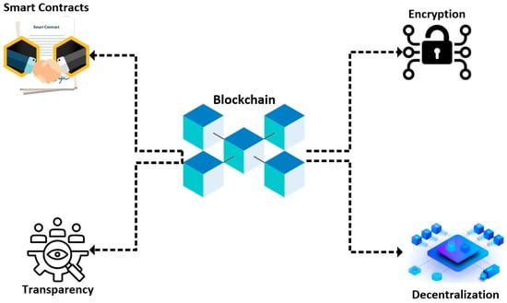
Diagram: Diverse Applications of BitTorrent Technology

The diagram illustrating the various applications of BitTorrent technology, including content delivery, software distribution, data backup, live streaming, blockchain, and scientific research
Real-world Example: BitTorrent in Scientific Research
Scientists often work with massive datasets that are difficult to share and distribute. BitTorrent provides an efficient solution by allowing researchers to share large files directly with each other, reducing the strain on servers and accelerating data dissemination.
Conclusion
BitTorrent's core technology, with its decentralized approach and efficient file distribution, has proven to be adaptable to a wide range of applications. By leveraging the power of peer-to-peer networks, BitTorrent continues to shape the way we consume and share digital content.
Q2) Write a report on Case Study of Netflix. Write detailed working with diagrams.

